**Project Design Phase-II**

**Technology Stack (Architecture & Stack)**

|  |  |
| --- | --- |
| Date | 03 October 2022 |
| Team ID | PNT2022TMID36311 |
| Project Name | Project – Nutrition Assistant Application |
| Maximum Marks |  |

**Technical Architecture:**

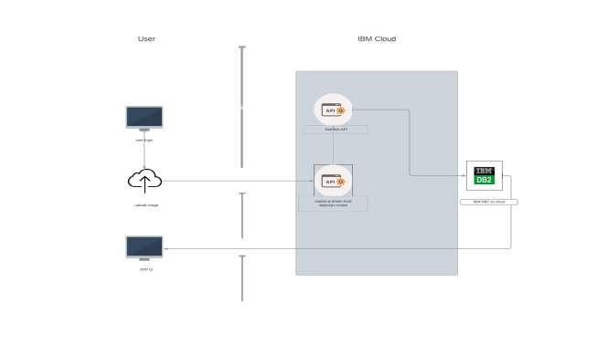

|  |  |  |  |
| --- | --- | --- | --- |
| **S.No** | **Characteristics** | **Description** | **Technology** |
| 1. | Open-Source Frameworks | Cloud stack, Eucalyptus. Open Nebula, App Scale, Docker | Docker |
| 2. | Security Implementations |  | e.g. SHA-256, Encryptions, Secure Authorization |
| 3. | Scalable Architecture | Handle large number of user on demand | Container registry, Kubernetes |
| 4. | Availability | The application can be accessed from anywhere at any | Docker |

**Table-1 : Components & Technologies:**

|  |  |  |  |
| --- | --- | --- | --- |
| **S.No** | **Component** | **Description** | **Technology** |
| 1. | User Interface | How user interacts with application e.g. Web UI, Mobile App, Chatbot etc. | HTML, CSS, JavaScript |
| 2. | Application Logic-1 | Logic for a process in the application | Python |
| 3. | Database | Data Type, Configurations etc. | SQL, |
| 4. | Cloud Database | Database Service on Cloud | IBM DB2 |
| 5. | External API-1 | To identify food ingredients | Clarifai's AI-Driven Food Detection Model |
| 6. | External API-2 | To calculate nutrition | Nutrition API |
| 7. | Infrastructure (Server / Cloud) | Application Deployment on Local System / Cloud Local Server Configuration:  Cloud Server Configuration : | Local, Cloud Foundry, Kubernetes, etc. |

**Table-2: Application Characteristics:**

|  |  |  |  |
| --- | --- | --- | --- |
| **S.No** | **Characteristics** | **Description** | **Technology** |
|  |  | time. |  |
| 5. | Performance | Deploy clusters closer to users to reduce latency. Use optimized images with the minimal components needed to run your workload. Run multiple Kubernetes masters to improve performance and availability | Kubernetes |